**VELOCITY CORPORATE TRAINING CENTER, PUNE**

**GROUP G**

**QUIZ APPLICATION PROJECT**

**USER MANUAL**

**MADE BY :**

**DHANASHREE DAREKAR**

**DIVYASHREE SURKAR**

**ANJALI SHIRSATH**

**INTRODUCTION**

Welcome to the G's Group Quiz Application Project. This application is designed to provide a platform for users to participate in quizzes and for administrators to manage quizzes and user accounts.

**Technology Used :** Core Java, MySQL

**Concepts Used :**

1. Object-Oriented Programming (OOP)

a) Abstraction:

The Admin class encapsulates administrative functionalities, abstracting away the implementation details.

b) Encapsulation:

The Admin class encapsulates data such as admin username and password, providing methods to interact with this data.

2. Packages

com.demo.project package

com.demo.project.admin package

com.demo.project.user package

com.demo.project.databaseconnection package

com.demo.project.exceptionhandler package

3. Control Statements

if-else statements and switch-case statements

4. Exception Handling

try-catch blocks for handling exceptions

Creating and handling custom exceptions with custom exception classes

5. Input/Output

Scanner class for user input

System.out.println for displaying output

6. Database Connectivity

JDBC (Java Database Connectivity) for interacting with a database

Establishing connections, executing SQL queries, retrieving data, and performing database operations

7. Collections

ArrayList and List for efficient storage and manipulation of objects

8. SQL Queries

Constructing SQL queries for database operations

9. Comparator

Custom StudentScoreComparator class implementing the Comparator interface for comparing StudentScore objects

10. Enhanced For Loop (For-each Loop)

Iterating over a list using an enhanced for loop (for-each loop)

**WORKING**

The Quiz Application Project will start with a home page having title “***Welcome to G's Group Quiz Application Project***”. It is divided into 2 sections :

1. User Section

To access the user section of the quiz application, follow these steps:

1. From the main menu, select the "User" option.
2. First you will have to do student registration.
3. Then you will have to do student login with your correct username and password.
4. As a user, your role is to answer quiz questions.
5. Follow the instructions provided by the application to proceed with the quiz.
6. At the end of the quiz, the application will display a score.

2. Admin Section

To access the admin section of the quiz application, follow these steps:

1. From the main menu, select the "Admin" option.
2. As an admin, you can see the student details, you can fetch the details of a particular student with his/her id.
3. Use the admin interface to perform tasks such as adding questions for a quiz.

3. Exiting the Application

To exit the quiz application, follow these steps:

1. From the main menu, select the "Exit" option.

2. The application will display a farewell message.

3. Thank you …Visit again

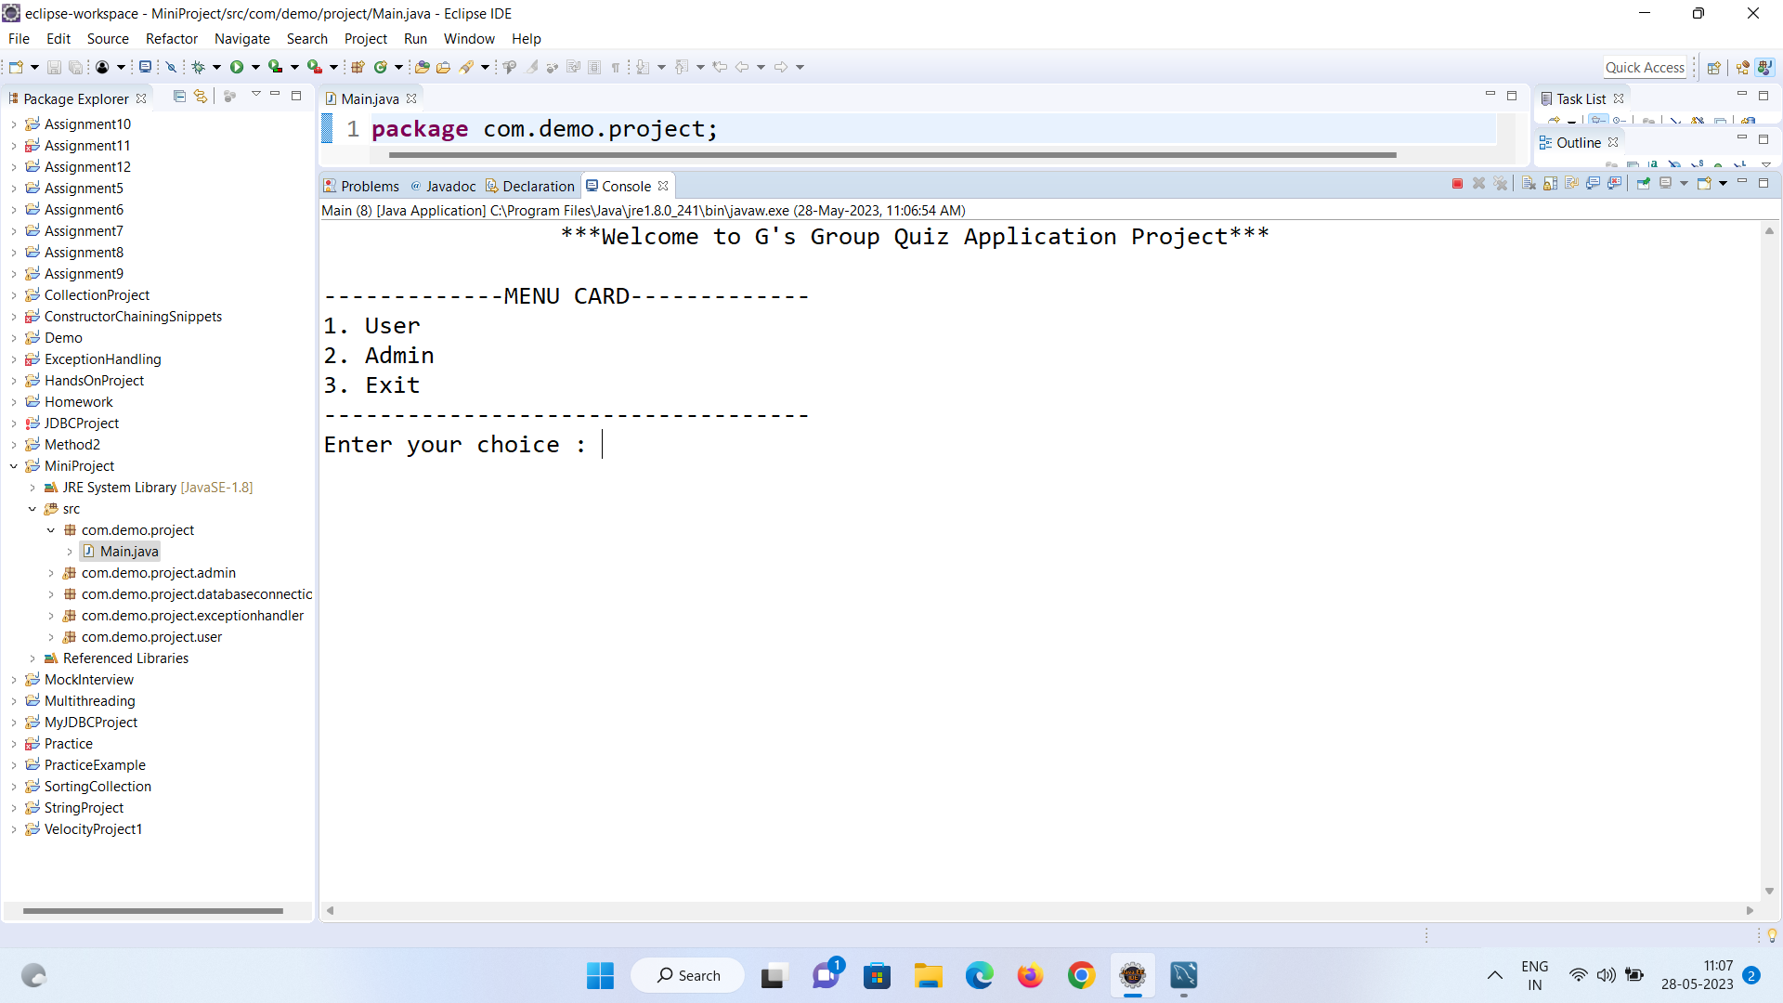

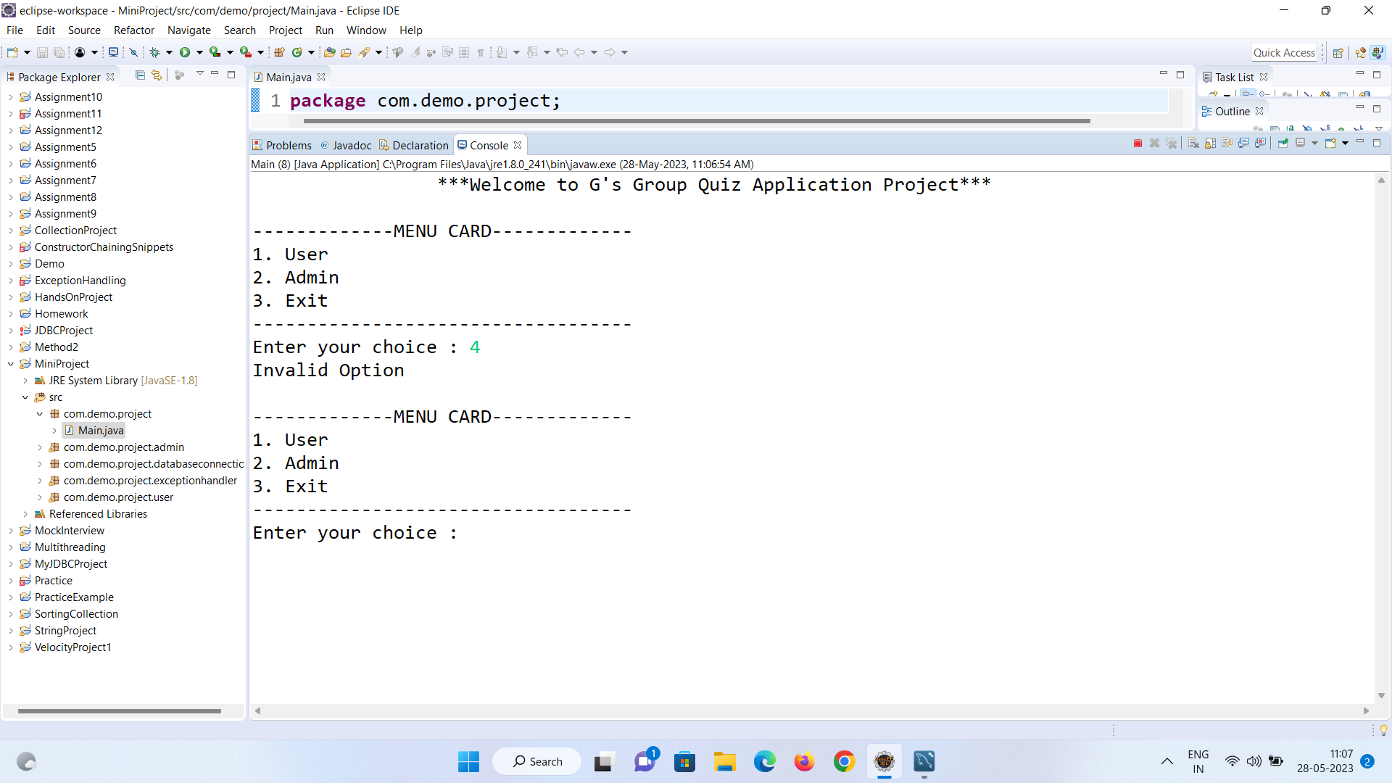

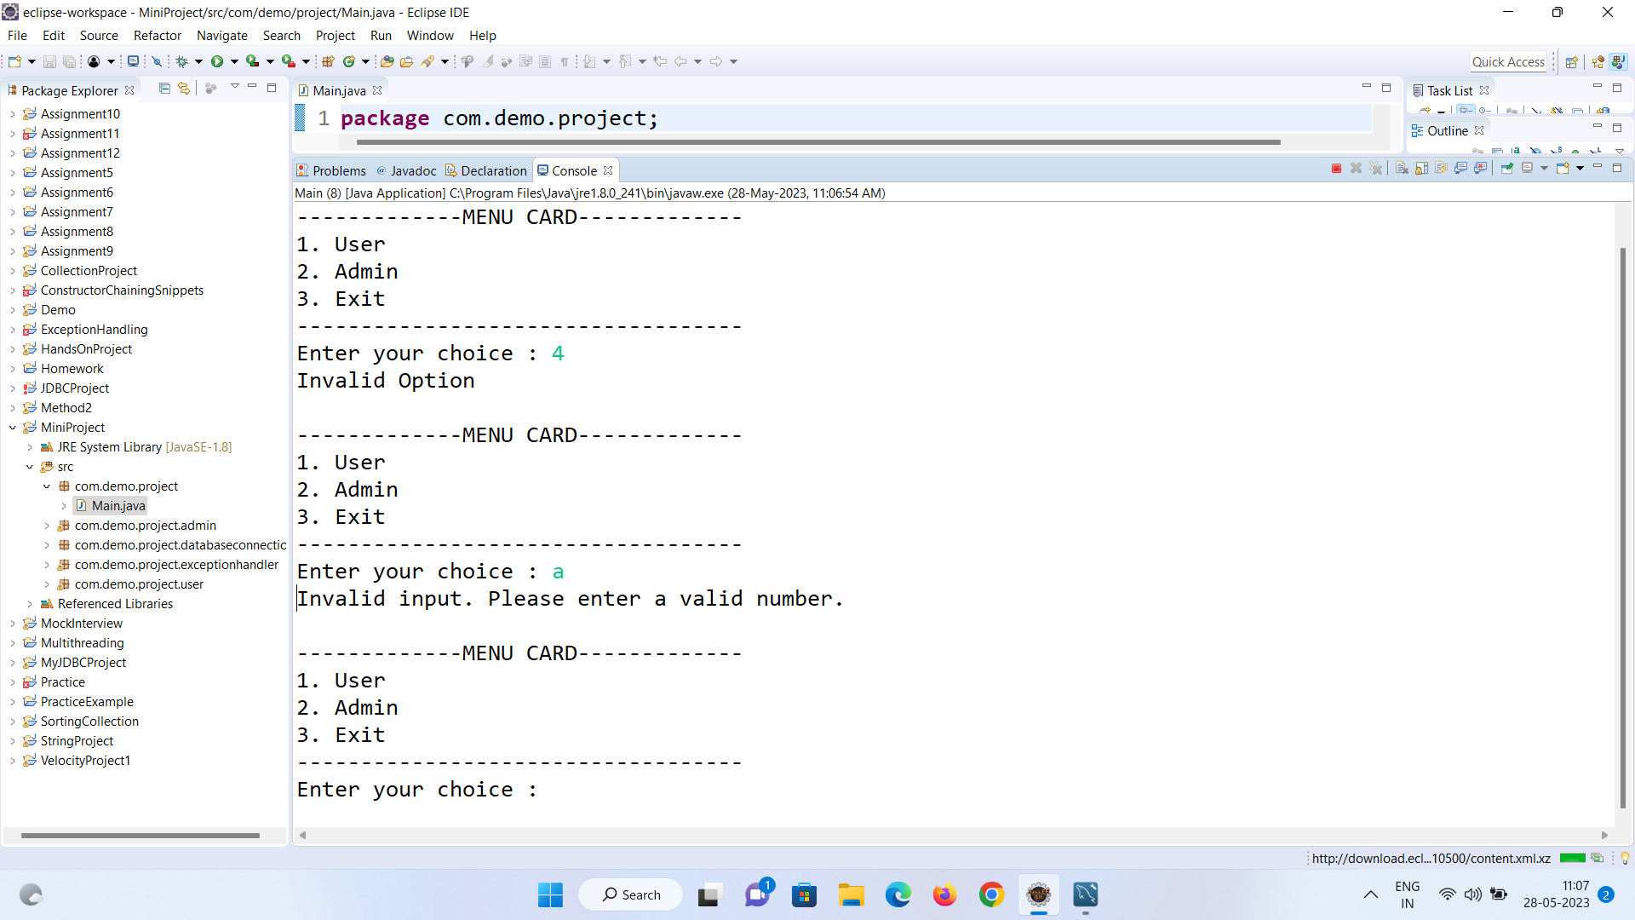

User Section:

The User section of the quiz application allows students to register and login to participate in quizzes. Follow the steps below to use the User section:

1. Accessing the User Section:

- Upon launching the application, you will see the main menu.

- From the main menu, select the "User" option by entering `1`.

2. User Menu:

- Once you access the User section, you will see the User menu.

- The User menu provides the following options:

- 1. Student Registration: Allows new students to register for the quiz application.

- 2. Student Login: Allows registered students to log in to the quiz application and participate in quizzes.

- 3. Exit: Exit the User section and return to the main menu.

3. Student Registration:

- To register as a new student, select the "Student Registration" option by entering `1`.

The Student Registration feature allows new students to register for the quiz application. Follow the steps below to register as a student:

a. Student Registration Form:

- You will see the Student Registration Form displayed.

- Follow the instructions provided by the application to complete the registration process.

- Enter the following details when prompted:

- Id: Enter the student ID.

- First Name: Enter the student's first name.

- Last Name: Enter the student's last name.

- Username: Enter a unique username for the student.

- Password: Enter a password for the student's account.

- City: Enter the student's city.

- Mail ID: Enter the student's email address.

- Mobile Number: Enter the student's mobile number.

b. Submitting the Registration:

- After entering all the required details, submit the registration form.

- The application will validate and store the student's information in the database.

- You will see a confirmation message indicating that the student record has been successfully inserted.

c. Completing the Registration:

- The student registration process is now complete.

- The student can now use their registered username and password to log in to the quiz application.

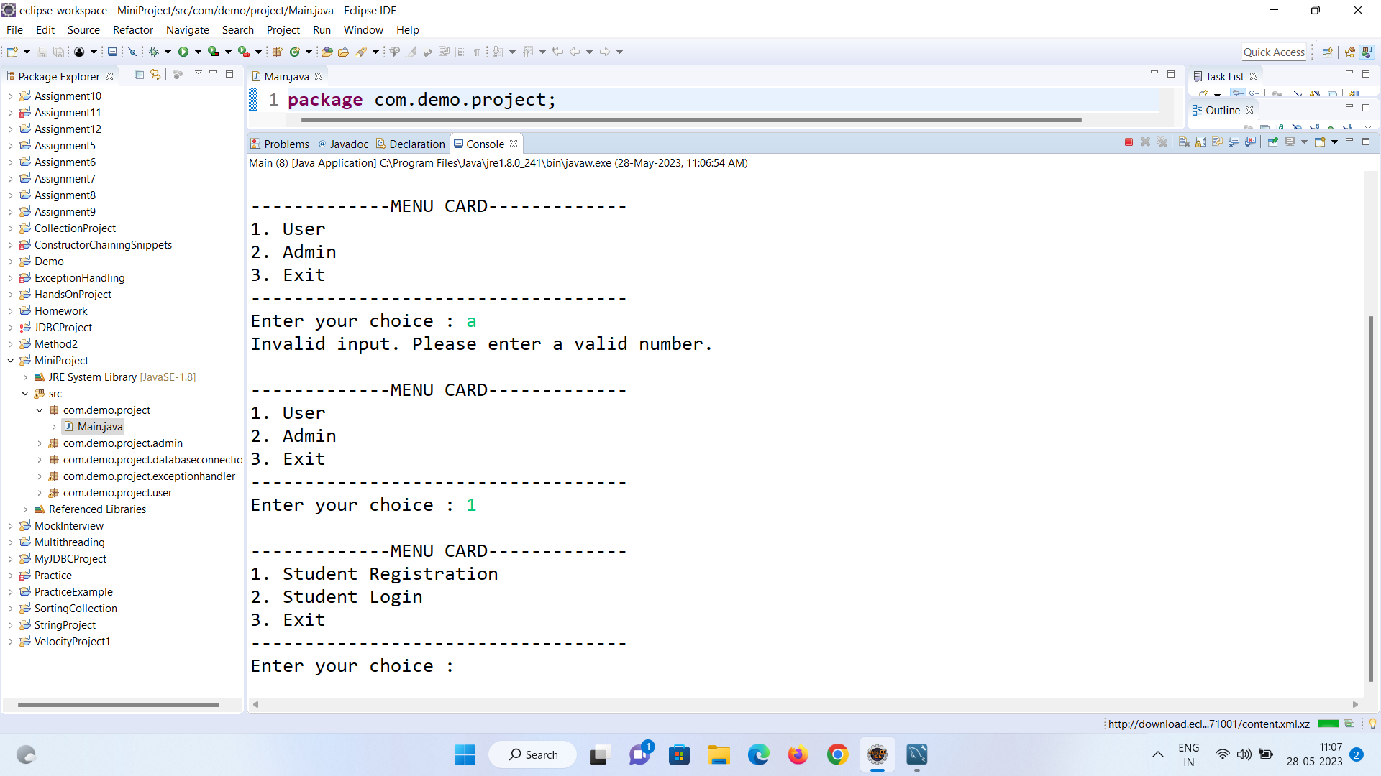

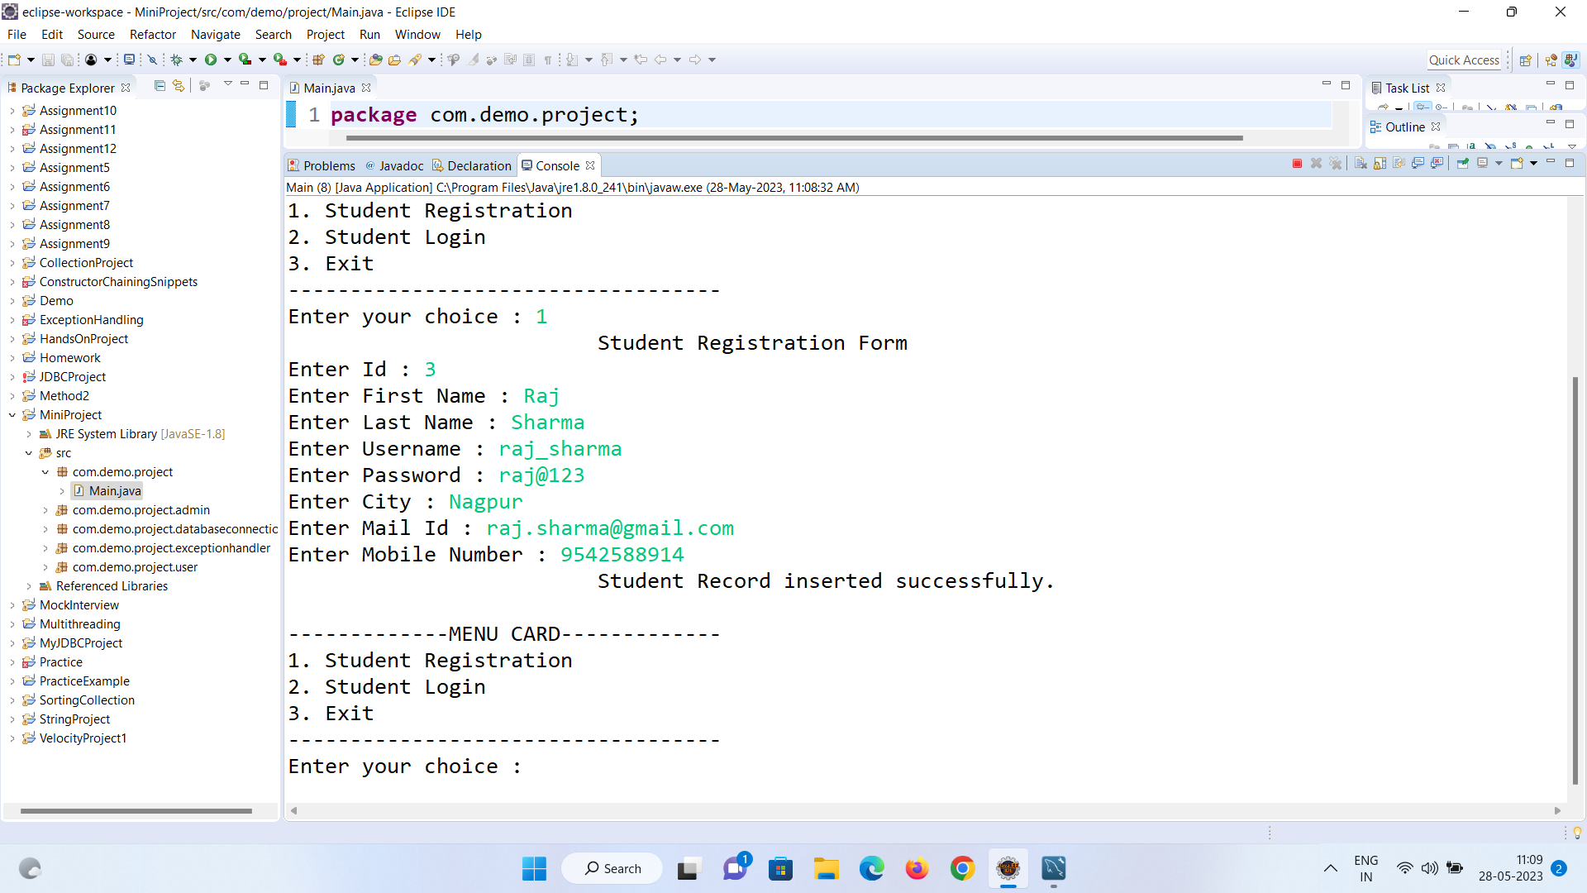

4. Student Login:

- If you are already a registered student, select the "Student Login" option by entering `2`.

The Student Login feature allows registered students to log in to the quiz application. Follow the steps below to log in as a student:

a. Student Login:

- You will see the Student Login prompt displayed.

- Enter your username and password when prompted.

- Username: Enter your registered username.

- Password: Enter your password associated with the account.

b. Validating Credentials:

- The application will validate your entered username and password against the database.

- If the credentials are valid, you will see an access granted message.

- If the credentials are invalid, you will see an error message indicating that the username or password is incorrect.

c. Proceeding with User Functionalities:

- Upon successful login, you can proceed with further operations in the quiz application.

- You will gain access to user functionalities, such as taking quizzes and viewing quiz results.

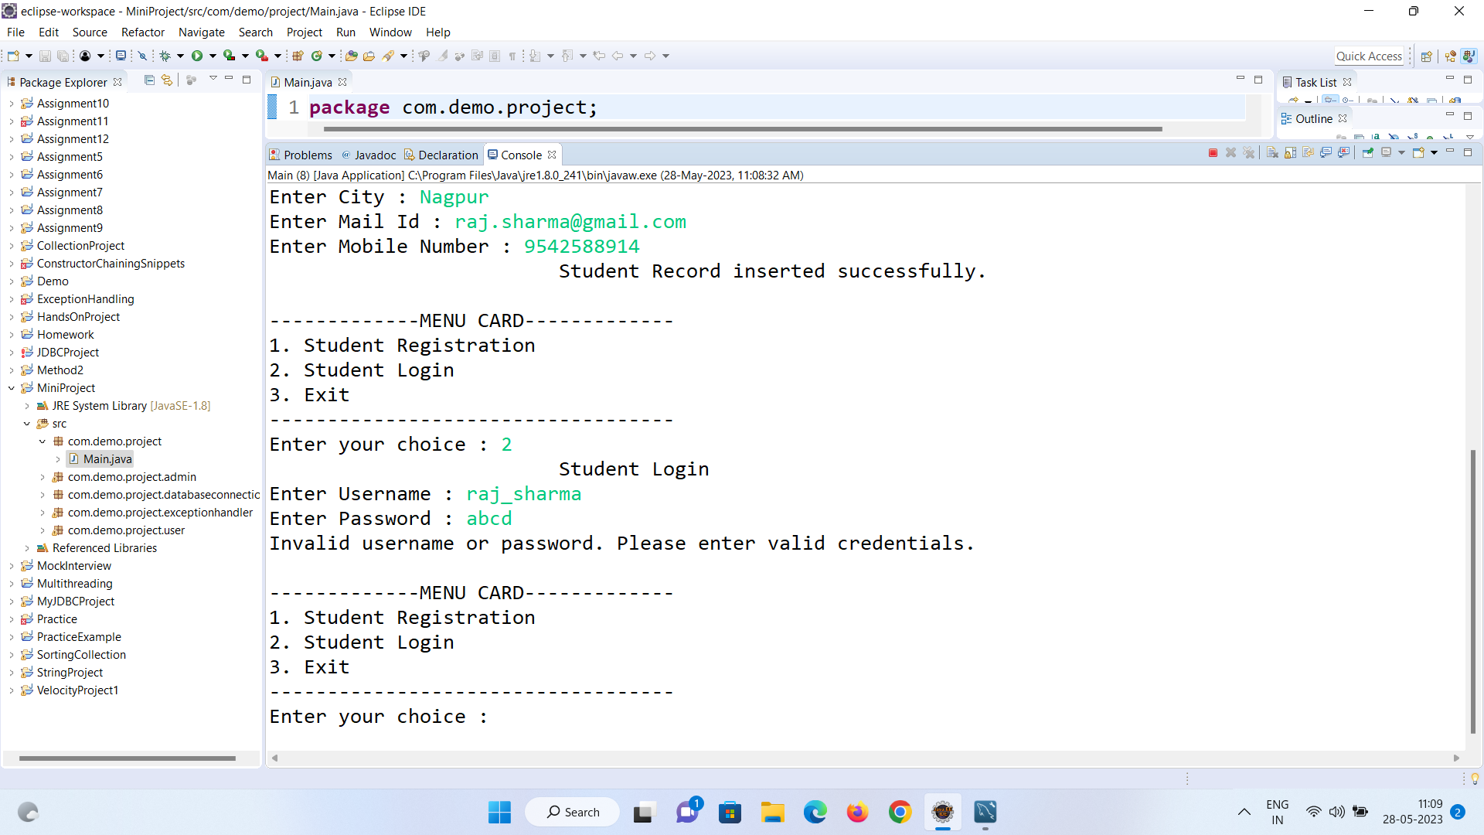

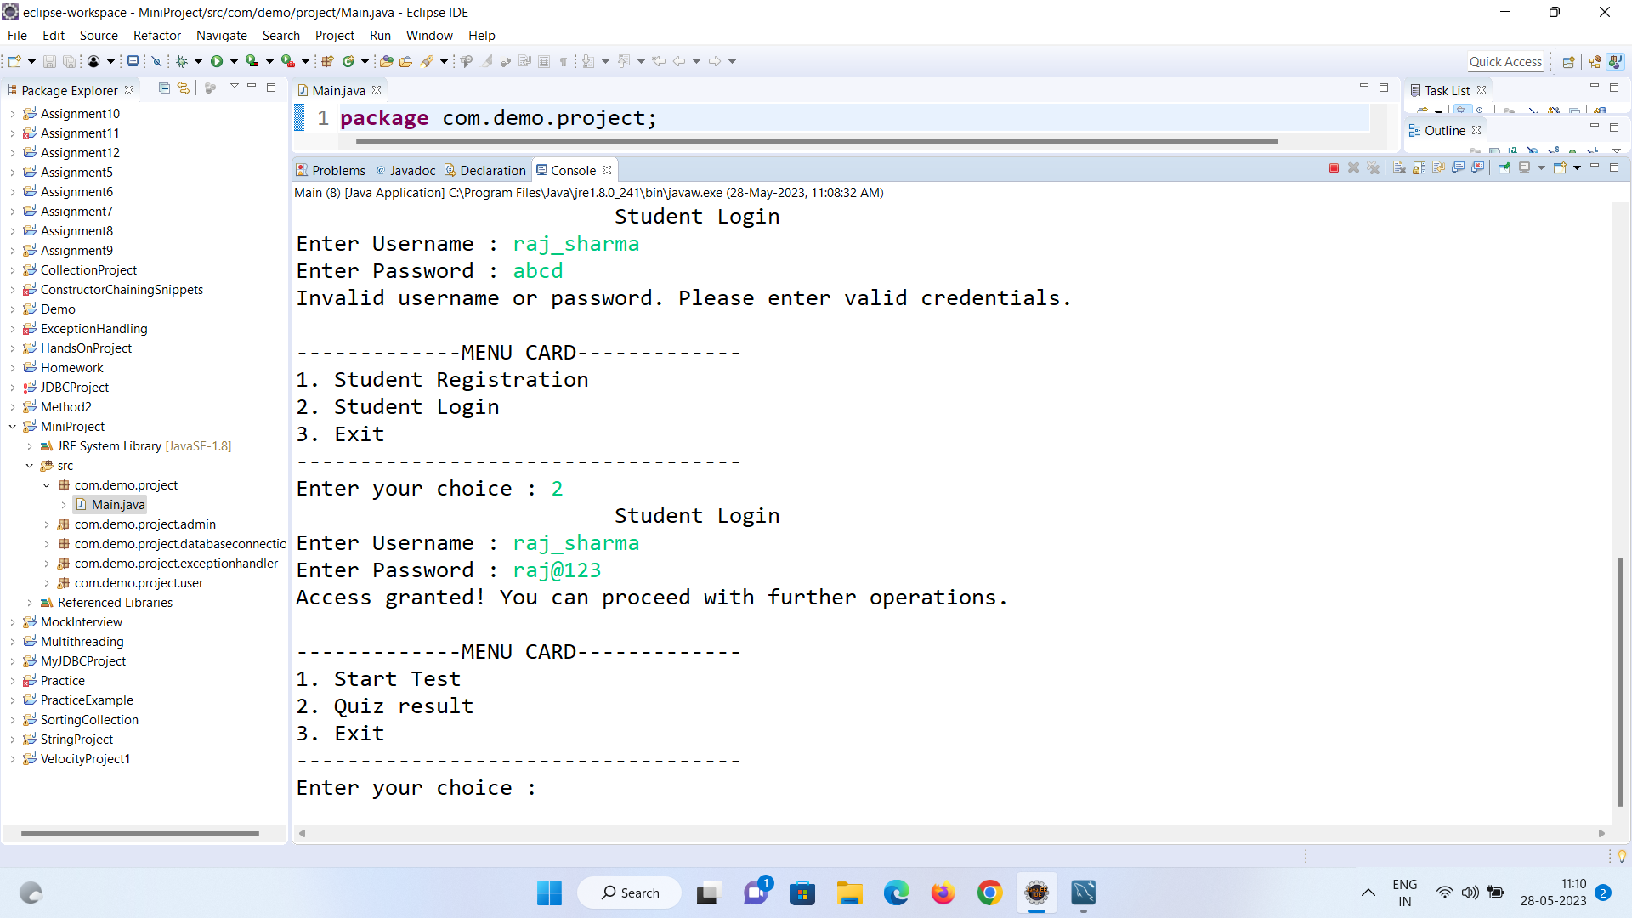

User Functionalities:

The User Functionalities section provides various options for users to interact with the quiz application. Follow the steps below to access and utilize these functionalities:

1. User Functionalities Menu:

- The menu options include the following:

- Start Test: Allows you to begin a quiz test.

- Quiz Result: Allows you to view your quiz results.

- Exit: Allows you to exit the User Functionalities section and return to the main menu.

2. Selecting an Option:

- Enter the corresponding number for the functionality you wish to access.

- For example, to start a test, enter "1". To view quiz results, enter "2".

- If you wish to exit the User Functionalities section, enter "3".

3. Performing the Chosen Action:

- Once you have selected an option, the application will perform the corresponding action.

- If you selected "Start Test", the application will display the quiz questions and allow you to answer them.

a. Accessing Display Questions:

- From the main menu, select the "User" option.

- In the User section, select the "Start Test" option.

b. Enter Student ID:

- The application will prompt you to enter your Student ID.

- Input your Student ID using the keyboard and press Enter.

c. Displaying Shuffled Questions:

- If the entered Student ID is valid, the application will retrieve a list of questions from the database and shuffle them.

- The shuffled questions will be displayed one by one.

- For each question, you will see the question text, along with four options (A, B, C, D).

d. Answering Questions:

- Enter the correct option (A, B, C, or D) for each question and press Enter.

- If the entered option is valid, the application will evaluate your answer and provide feedback (Correct or Incorrect).

- Repeat this process for all the questions in the quiz.

e. Quiz Result:

- After answering all the questions, the application will display the final quiz result.

- The result will show the number of correct answers you provided.

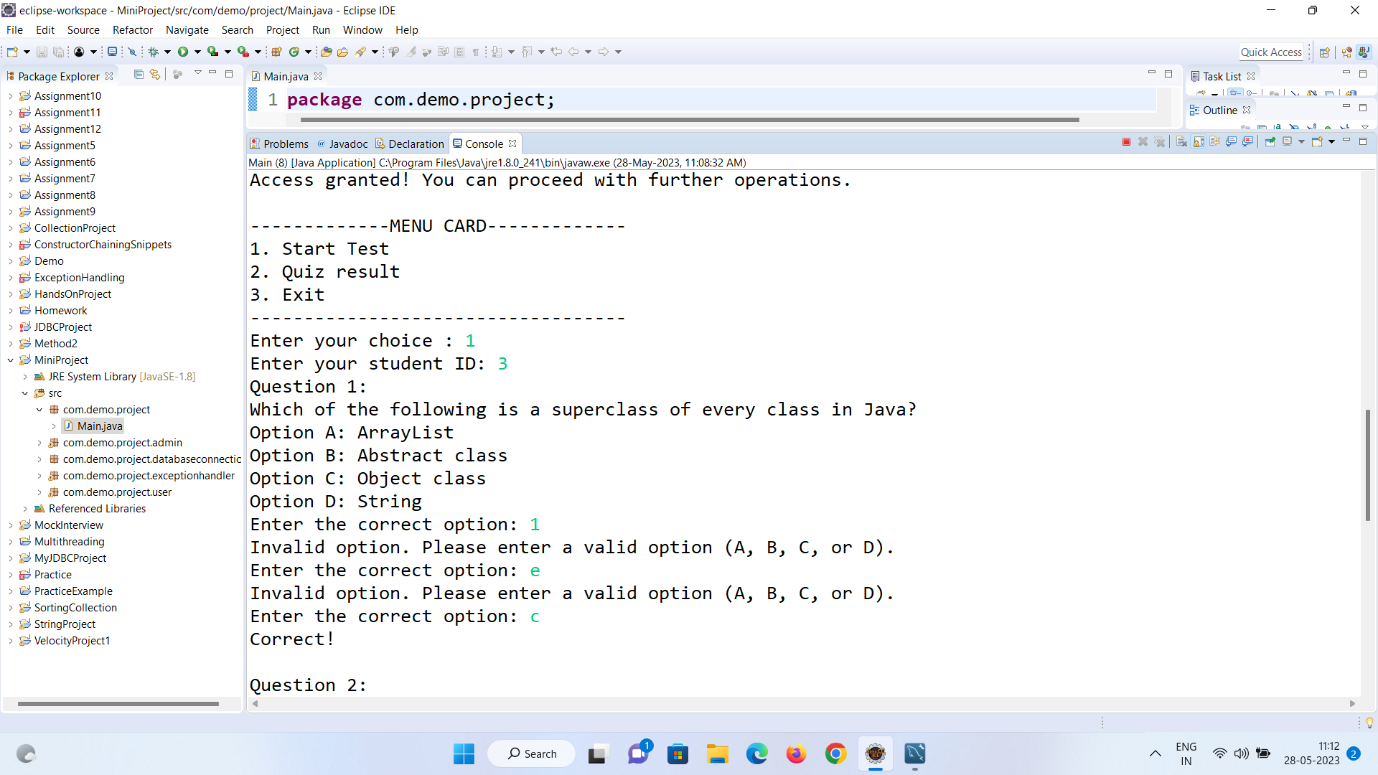

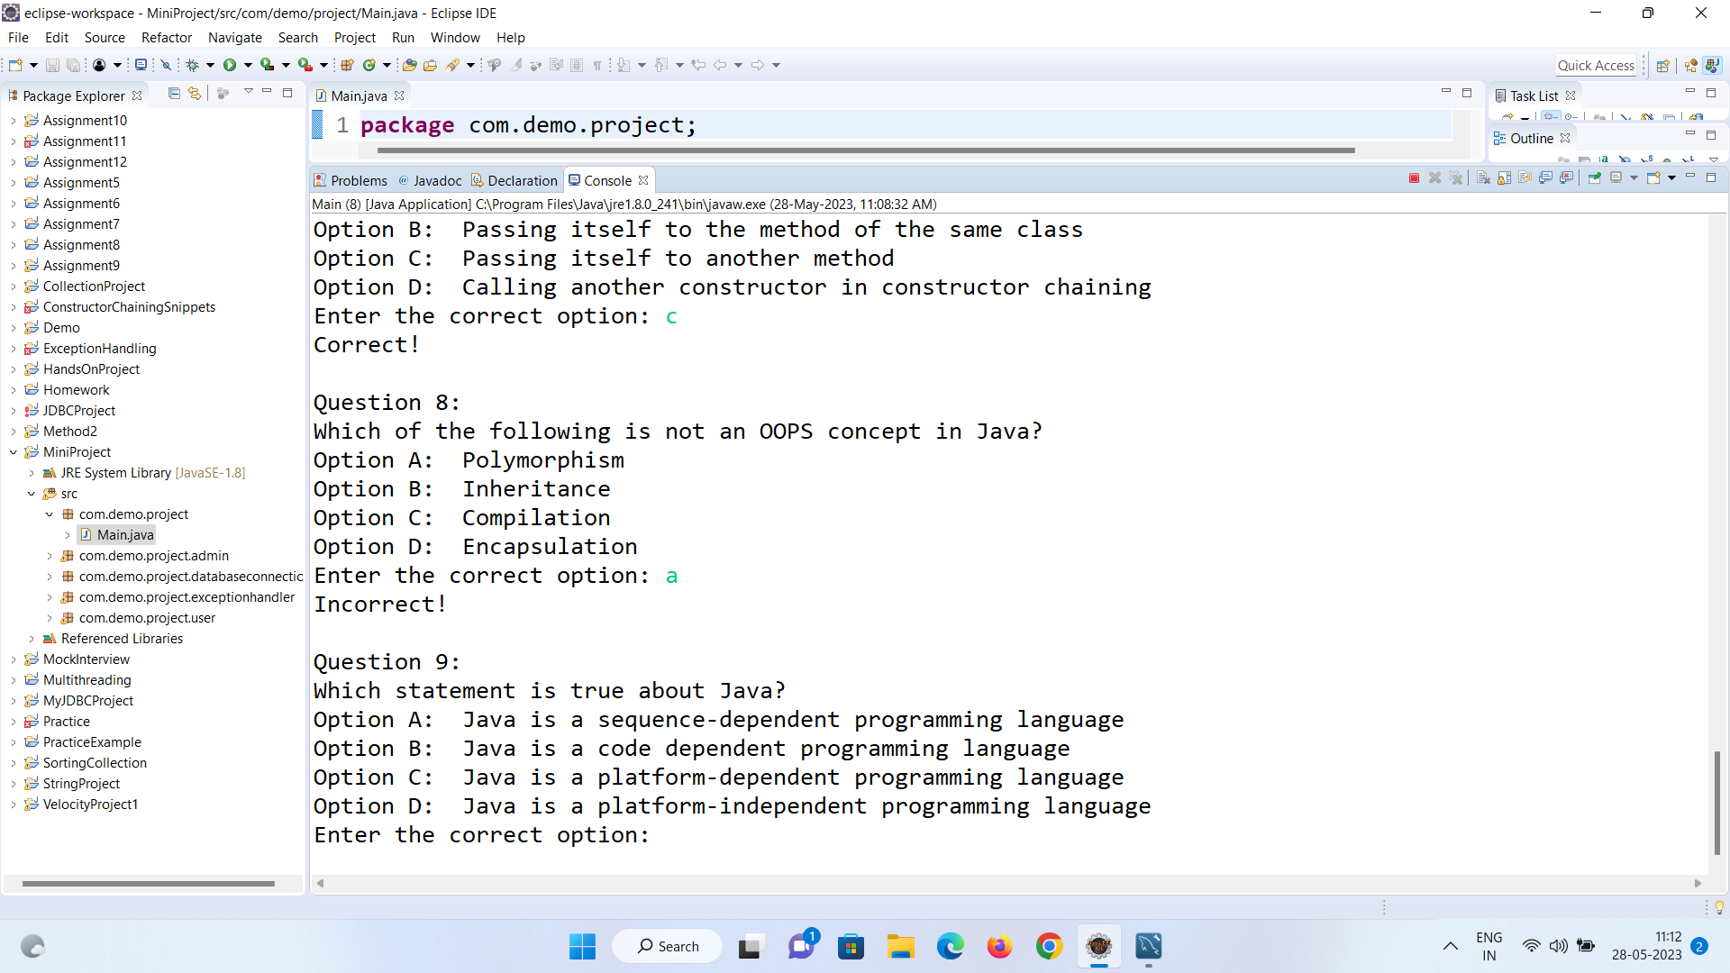

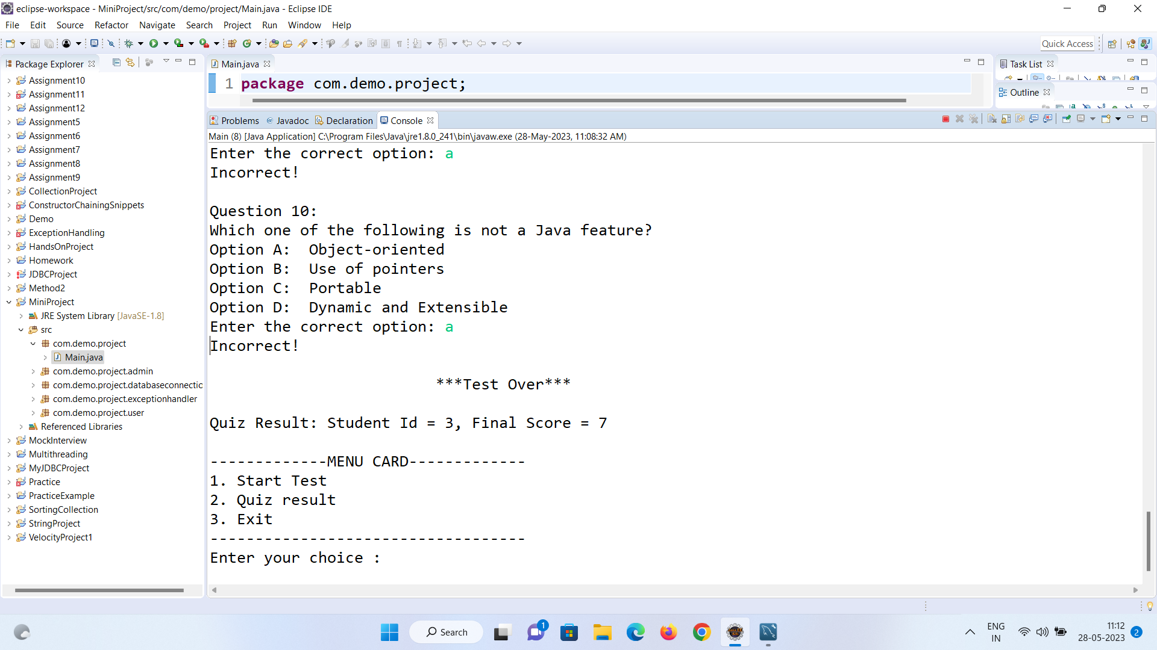

f. Return to Main Menu:

- Once the quiz is over and the result is stored, you will be returned to the main menu.

- If you selected "Quiz Result", the application will display the quiz result.

a. Accessing Quiz Results:

- From the main menu, select the "User" option.

- In the User section, select the "Quiz Result" option.

b. Displaying Student Scores:

- The application will retrieve the quiz results for all students from the database.

- The student scores will be displayed in descending order of their scores.

- Each student's rank, name, ID, and score will be shown.

c. Return to Main Menu:

- After displaying the quiz results, you will be returned to the main menu.

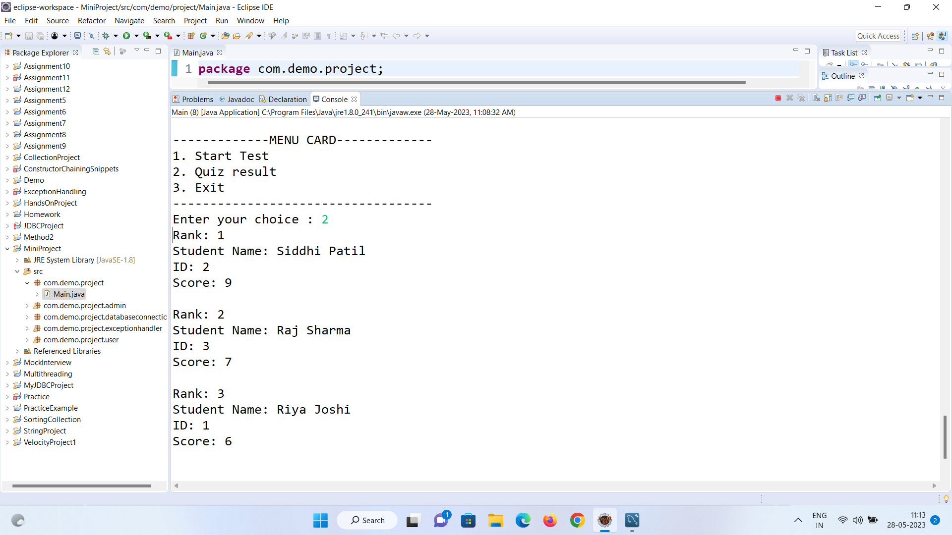

Admin:

The Admin class provides functionality specifically designed for administrators of the quiz application. As an administrator, you have access to various features that allow you to manage and monitor student scores, add new questions to the quiz. Follow the steps below to utilize the features provided by the Admin section:

1. Accessing Admin Features:

- From the main menu, select the "Admin" option.

- In the Admin section, you will see a menu with multiple options.

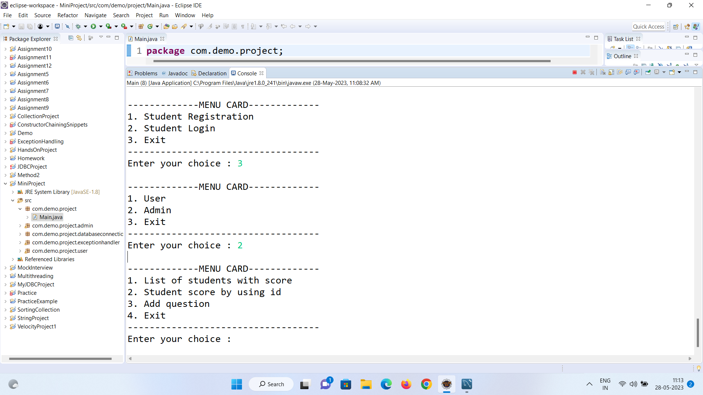

2. List of students with score:

- Select the "List of students with score" option.

- The application will retrieve the list of students along with their respective scores from the database.

Follow the steps below to access and utilize this feature:

a. Accessing Student Scores:

- From the main menu, select the "Admin" option.

- In the Admin section, select the "List of students with score" option.

b. Retrieving Student Scores:

- The application will fetch the scores of all students from the database.

- The student scores will be sorted in ascending order of their scores.

c. Displaying Student Scores:

- Each student's details, including their ID, name, username, password, city, email ID, mobile number, and score, will be displayed.

- The student scores will be shown in ascending order of their scores.

d. Return to Admin Menu:

- After displaying the student scores, you will be returned to the Admin menu.

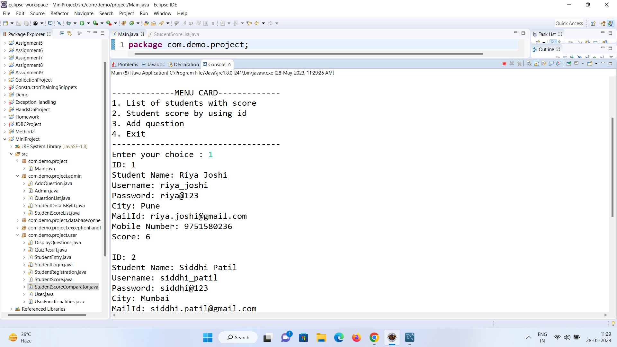

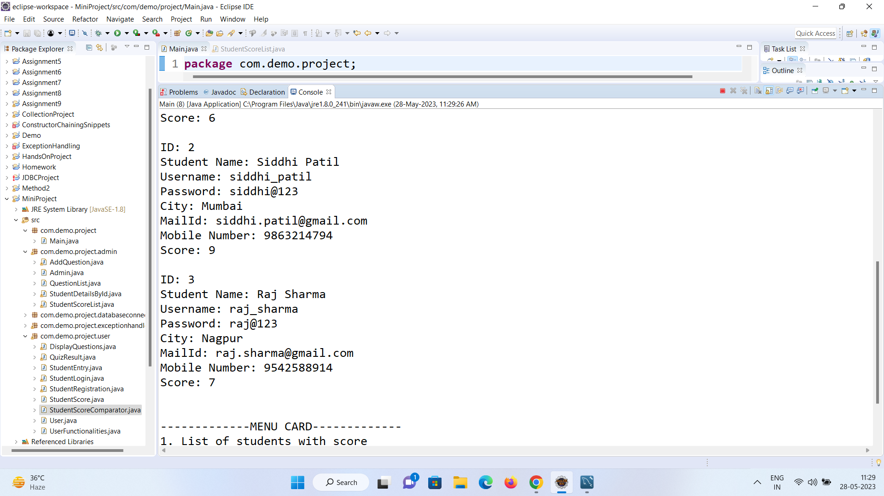

3. Student score by using ID:

- Select the "Student score by using ID" option.

- Enter the student's ID to retrieve their score.

- The application will fetch the student's score from the database and display it.

Follow the steps below to access and utilize this feature:

a. Accessing Student Details by ID:

- From the main menu, select the "Admin" option.

- In the Admin section, select the "Student score by using ID" option.

b. Enter Student ID:

- You will be prompted to enter the ID of the student whose details you want to view.

- Provide the student ID as input and press Enter.

c. Retrieving Student Details:

- The application will retrieve the details of the student with the provided ID from the database.

- The student's ID, first name, last name, username, password, city, email ID, and mobile number will be displayed.

d. Retrieving Student Score:

- The application will also fetch the score of the student from the database.

- If a score is found, it will be displayed.

- If no score is found, an appropriate message will be displayed.

e. Return to Admin Menu:

- After displaying the student details and score, you will be returned to the Admin menu.

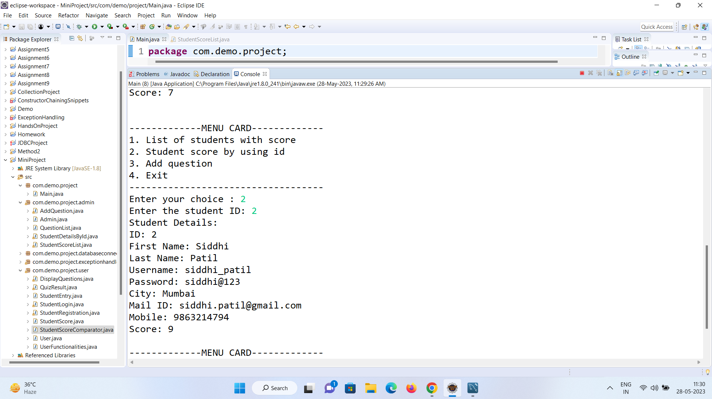

4. Add question:

- Select the "Add question" option.

- You will be prompted to enter the new question and its options.

- Provide the correct answer for the question.

- The application will store the new question in the database for future quizzes.

Follow the steps below to access and utilize this functionality:

a. Accessing Add Question:

- From the main menu, select the "Admin" option.

- In the Admin section, select the "Add question" option.

b. Enter Question Details:

- You will be prompted to enter the question details.

- Provide the following information:

- Question: Enter the question text.

- Option A: Enter the text for option A.

- Option B: Enter the text for option B.

- Option C: Enter the text for option C.

- Option D: Enter the text for option D.

- Correct Option: Enter the correct option (A, B, C, or D) for the question.

c. Adding the Question:

- The application will connect to the database and execute an insert query to add the question to the question list.

- The question and its details will be stored in the database.

d. Confirmation Message:

- Upon successful insertion, a confirmation message will be displayed indicating that the question has been added successfully.

e. Return to Admin Menu:

- After adding the question, you will be returned to the Admin menu.

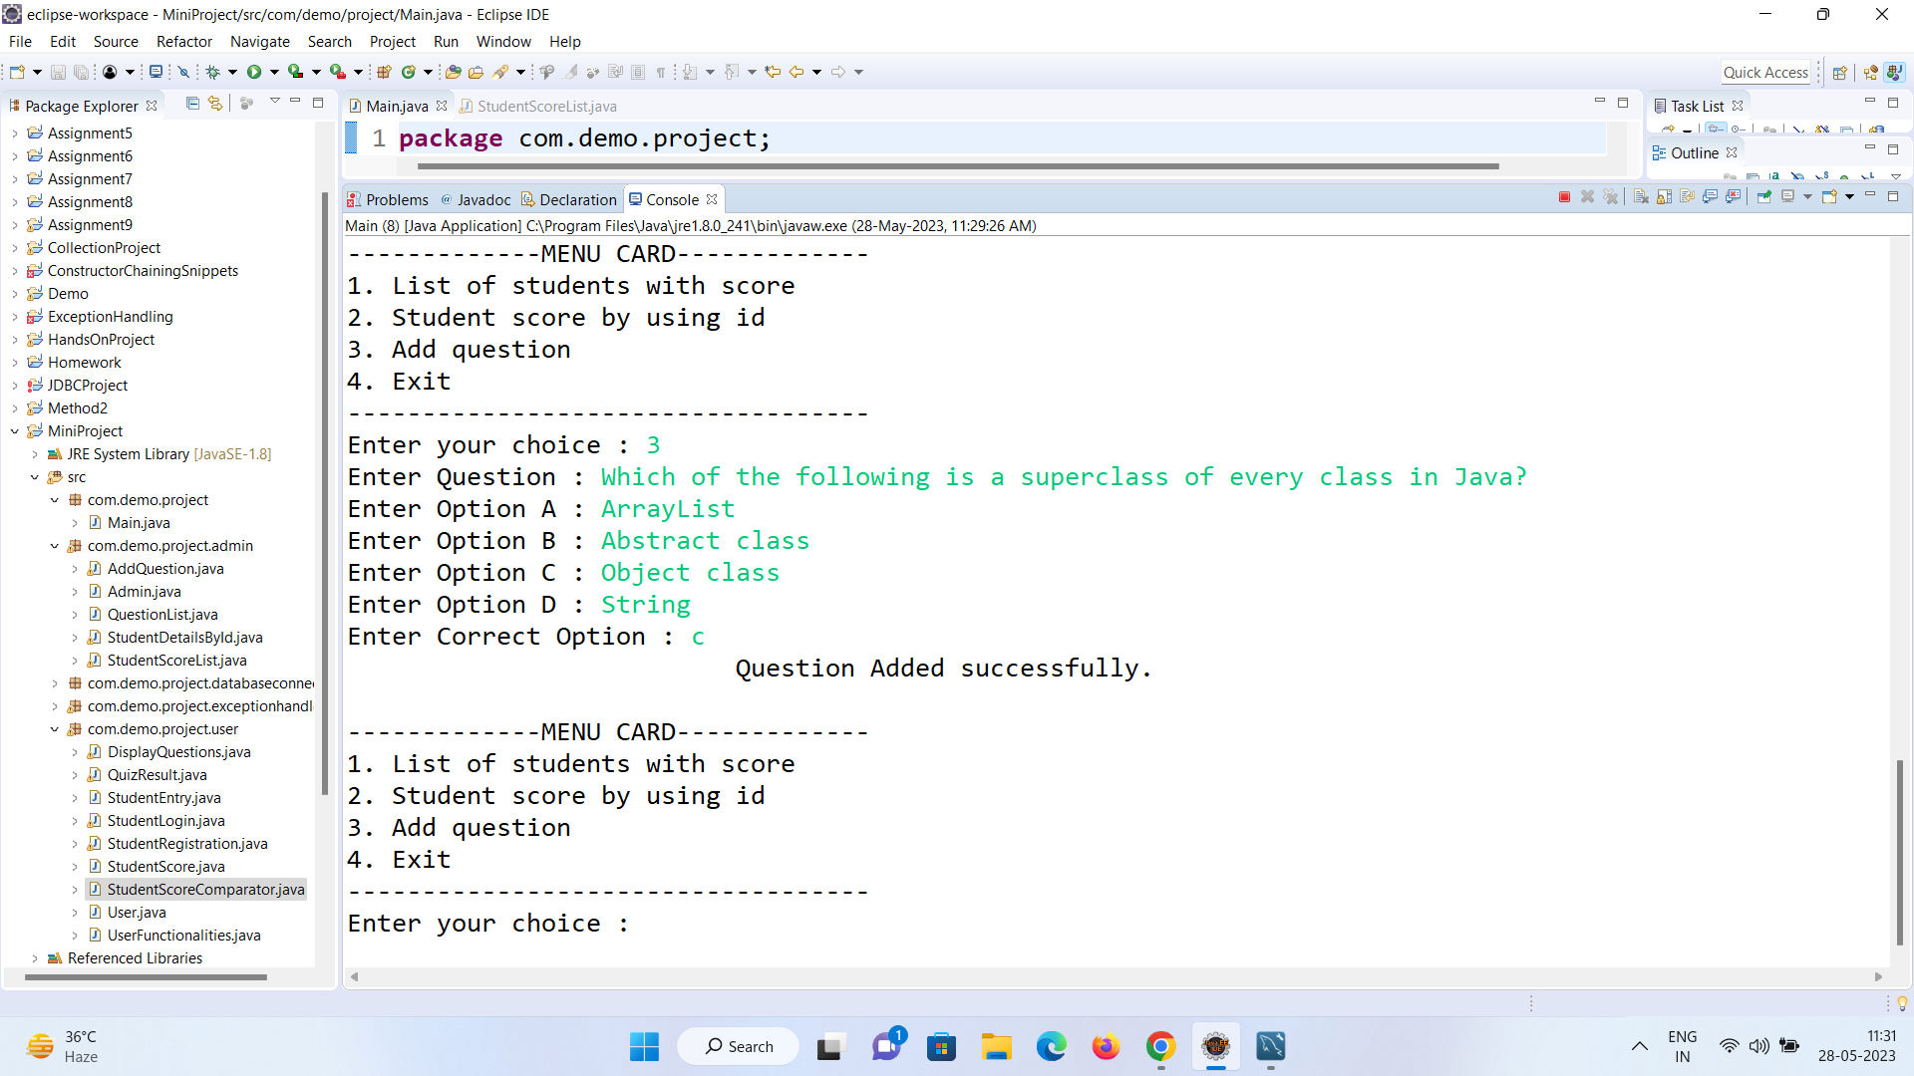

6. Exit:

- Select the "Exit" option to exit the Admin section and return to the main menu.

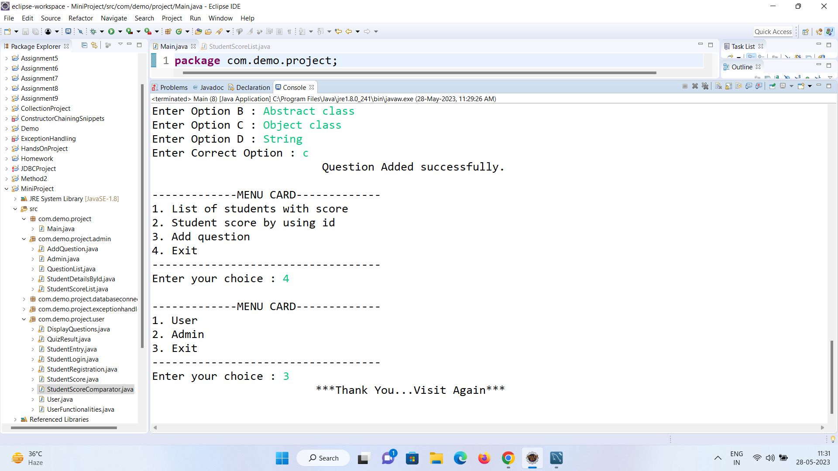

In conclusion, this user manual serves as a comprehensive guide for utilizing the Quiz Application. It covers various aspects of the application, including installation, launching, user registration, login functionality, quiz-taking process, and admin functionalities such as managing student scores and adding questions.

By following the instructions and guidelines provided in this manual, users can effectively navigate and make use of the Quiz Application to enhance their learning experience.